ME424 Project 1 Report

11912404 江轶豪

1. Wind Power Forcast

solution：

1. Data:

From the attachment “project1_1.ipynb” below, we import the data of the second column in the .csv file.



1. Identification:

Assuming that for the k-th wind speed data, it is correlated with the (k-n)-th to (k-1)-th data. Then the equation can be written as below:



In the matrix form:



And if we expand the matrix and apply first 5000 wind speed data into the matrix, we will get:



where



From n = 1 to n = 2, the error will be estimated into the formula:



And then compare every err(n) to get the minimum one.

Since for every n = k, the amount of their samples may not be the same, for example, for n = 1, the amount of the samples is 4999, while for n = 2, it is 4998, it is necessary to let the first test data begin with 21-st wind speed data.

Step 1 of the code:

To define an AR model in a range of 1 to 20, and finally calculate the error and then put them into the array:

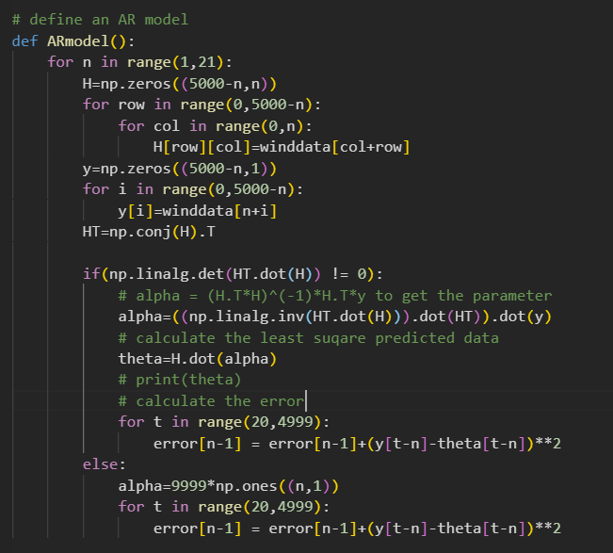

Step 2:

Get the minimum error, and also return the index of the error to get its “n”, where n = index + 1.

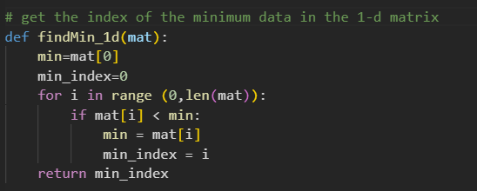

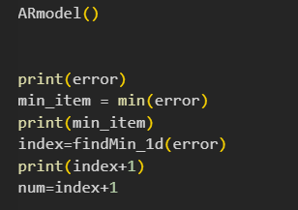

Step 3:

Get “n” and do the AR model again with the specific “n”, where n = 20.

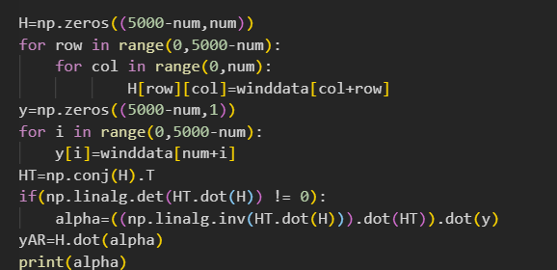

Step 4: draw the diagram project 1-1 requires: Plot err versus n

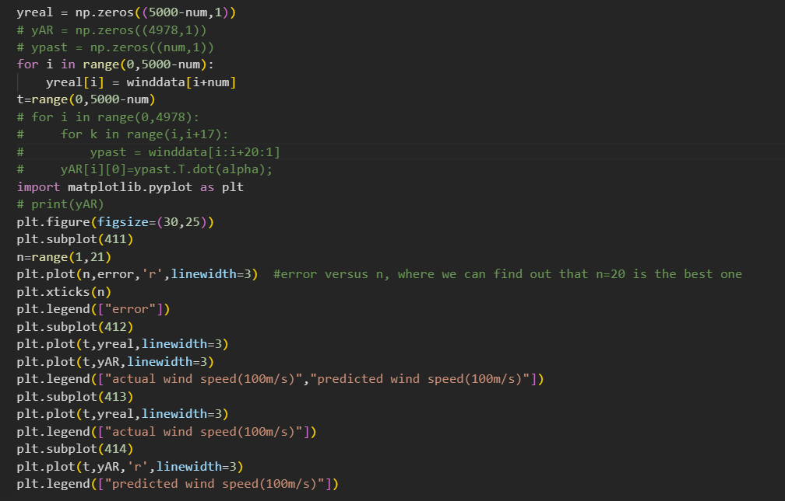

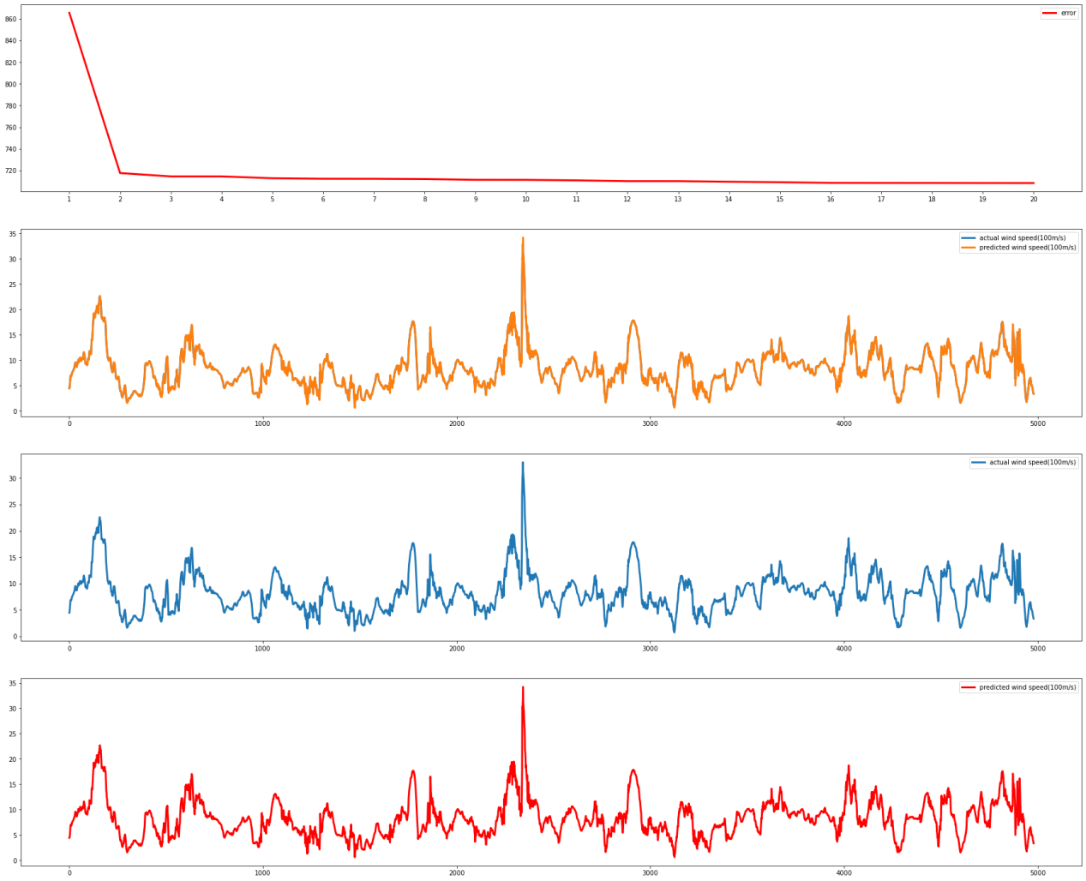

1. E911

(a)

The problem can be see as a nonlinear least square problem, where 

See the figure below:

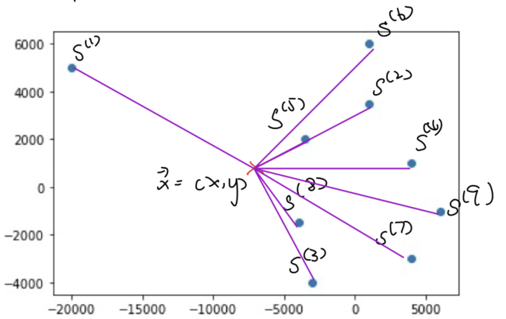



Let 

then we can choose a cost function:



Through the definition of the least square, we would findand 

1. There are two methods to calculate the least square location：
2. Convert the nonlinear least square problem into a linear one.
3. Solve the nonlinear least square problem by iteration applying python minimize method.

A: Linear optimization by the least square:



for 



for 



The first equation subtracts with the second one:



Then we can transform it into a matrix form and expand it:





Where , and the code is below:

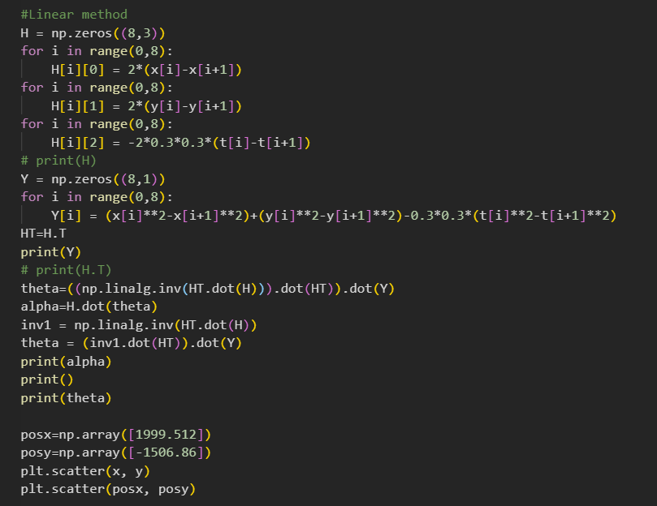

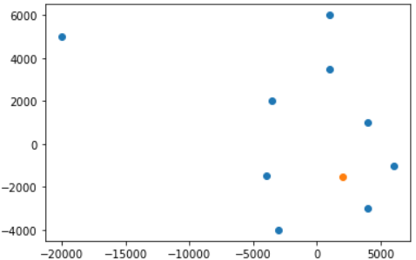

1. Nonlinear method:

In this method, what it matters is the code.

In this code, I choose the method of Basinhoping

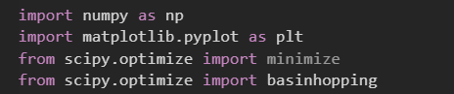

Since Basinhoping can help me find the global variable instead of the local extreme value.

Define the function of the error:

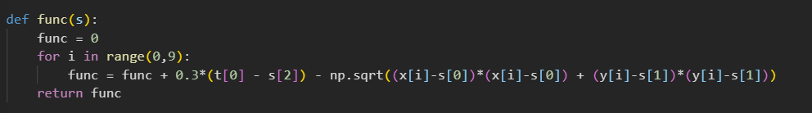

It is used to help me get the answer bounded:

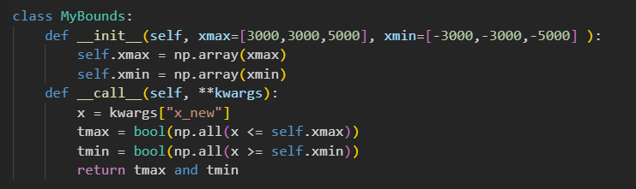

Find the minimum:

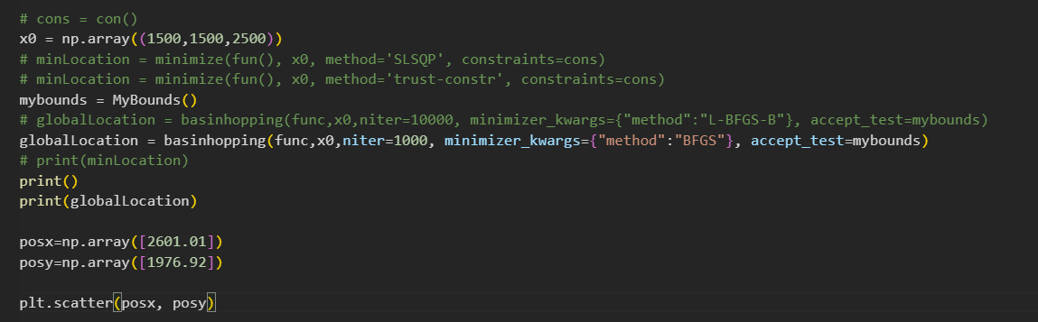



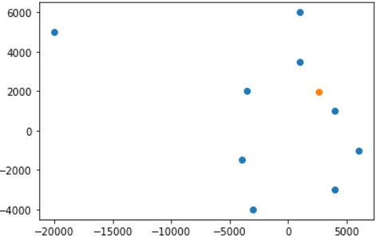

To sum up, the nonlinear method really requires the accuracy and the iteration times. So it is better to use the linear method.



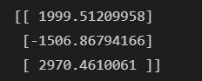

1. Robot Dynamics Simulation and Parameter Identification: